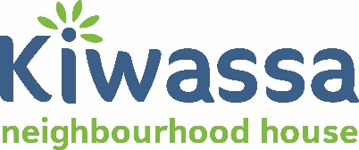

Community Income Tax Clinic - Volunteer Opportunity

Kiwassa Neighbourhood House is looking for Income Tax Clinic Volunteers. This position will support our Community Income Tax Clinic Program during March – April 2019, in collaboration with Canada Revenue Agency (CRA). Kiwassa is looking for volunteers who are comfortable working with numbers, have some basic accounting and/or tax experiences. Volunteers would be a great networking and learning opportunity and volunteers. Kiwassa will ensure volunteer recognition and provide reference letters and/or certificate of completion of the Tax Clinic to volunteers.
Experience and qualifications:
- Experience working with people from diverse backgrounds and familiarity with social service organizations
- Time management skills
- Comfortable working with numbers and processing income tax returns
- Some experience and/or training with completing income tax form and relevant forms
- Accounting or bookkeeping experience will be an asset
- Ability to problem solve and work independently
- Good computer skills
- Communication skills
- Knowledge of a second language will be an asset.
- Clear criminal record check

Main duties and responsibilities
- Committed to help clients, including, seniors, adults, newcomers, and people who need support to complete their Income Tax forms (basic and simple tax returns only)
- Apply and register as a Kiwassa volunteer and CRA’s Canadian Volunteer Income Tax Program (CVITP)
- Complete training that will be provided by CRA
- Attend a volunteer orientation session by Kiwassa
- Communicate with Kiwassa’ Volunteer Coordinator on ongoing basis during the Income Tax season

Time Commitment and Schedule
- Minimum 4 hours per week during tax season, March & April, 2019
- Prepare and communicate your weekly schedule of availability with Kiwassa so that appointments could be booked for your schedule
- The Community Volunteer Income Tax Clinic runs on weekdays during office hours 9:00am-5:00pm. It does not run during the evenings or on weekends

How to apply as a Volunteer for Income Tax Clinic?
If interested, please email Community and Volunteer Developer Vicky Li vickyl@kiwassa.ca your resume.

