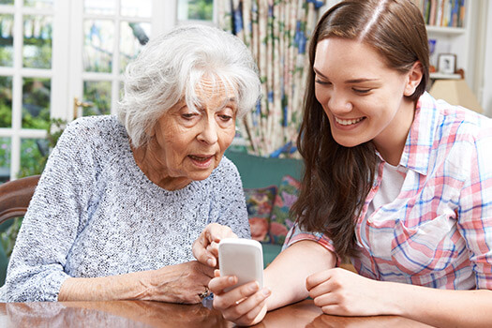
Senior Wellness Club 耆英健康俱乐部
Goal 目标：
- Addressing wellness issues
处理保健的相关问题
- Finding available resources
寻找可用的资源
- Increasing overall health
提高整体的健康
- Decreasing isolation
减少隔离性
Each senior will be paired up with a youth
每一位年长者会和一位青少年配对
You will get a chance to learn about each other’s life stories and hang out!
你将会有机会了解到对方的故事以及和对方出去消遣！
Youth volunteers will get volunteer hours and gain experience working with seniors!
January 18, 2019 & January 24, 2019 3-5pm 时间：1月18号和1月24号 下午三点到五点
Kiwassa Neighbourhood House, 2425 Oxford Street, Vancouver BC (地址)

Contact Cherrie or Ryan at 604-254-5401 for more information!
请联系Cherrie登记！

