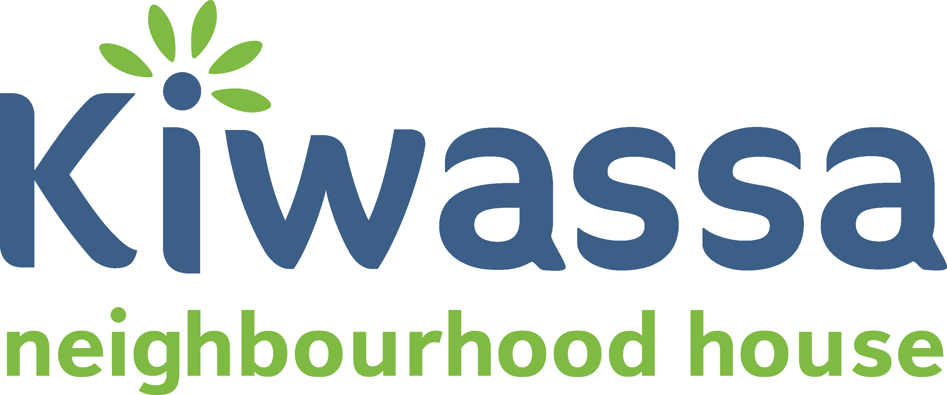  Youth Programs | 2019
@Kiwassa_Youth
Kiwassa Neighbourhood House – Youth Programs
Wednesday | Thursday |  | Friday | Saturday
3 | 4 |  | 5 | 6
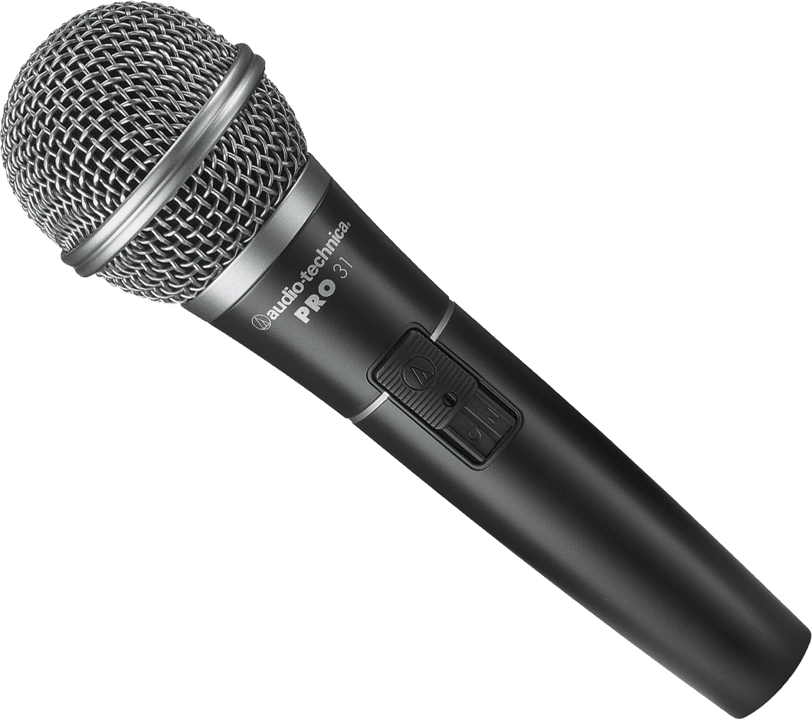  VISIT THE ‘HIP HOP DROP’  1739 Venables St.  5:30 – 9:30 | SKATEBOARD CAMP  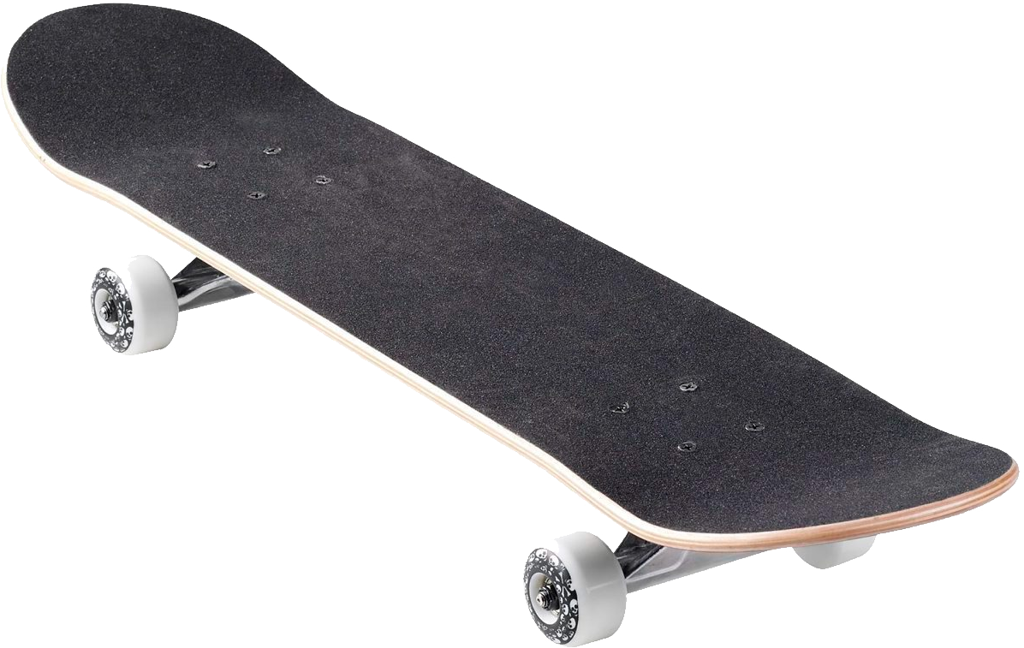  @ Flatspot Long Board Shop  1pm – 5pm |  | COMMUNITY MARKET  @ Kiwassa 3 – 7  *Volunteers Needed* | SUNRISE SUMMER KICK OFF  @ 2500 Franklin St  10 - 4
10 | 11 |  | 12 | 13
PING PONG  @ Kiwassa 3 - 6 | FRESH ROOTS  Farm Visit  12 – 2pm | SKATEBOARD CAMP  1pm – 5pm
17 | 18 |  | 19 | 20
MT. SEYMOUR HIKE  Meet @ Hastings CC  10am | SKATEBOARD CAMP  @ Flatspot Long Board Shop  1pm – 5pm |  | YOUTH VOICES WORKSHOP  @ Kiwassa  1pm – 4pm
24 | 25 |  | 26 | 27
SOCCER  13 – 16 year olds @ Trillium Fields  11 – 12:30 | SOCCER  13 – 16 yrs @ Trillium Fields  11 – 12:30 | SKATEBOARD CAMP  1pm – 5pm | SOCCER  13 – 16 year olds @ Trillium Fields  11 – 12:30 | CHESS GAMES  Youth vs. Seniors  @ Kiwassa 2pm – 4pm
30  MOVIE  @ Kiwassa 3 - 6 | 31  SKATEBOARD CAMP  @ Flatspot Long Board Shop  1pm – 5pm |  | 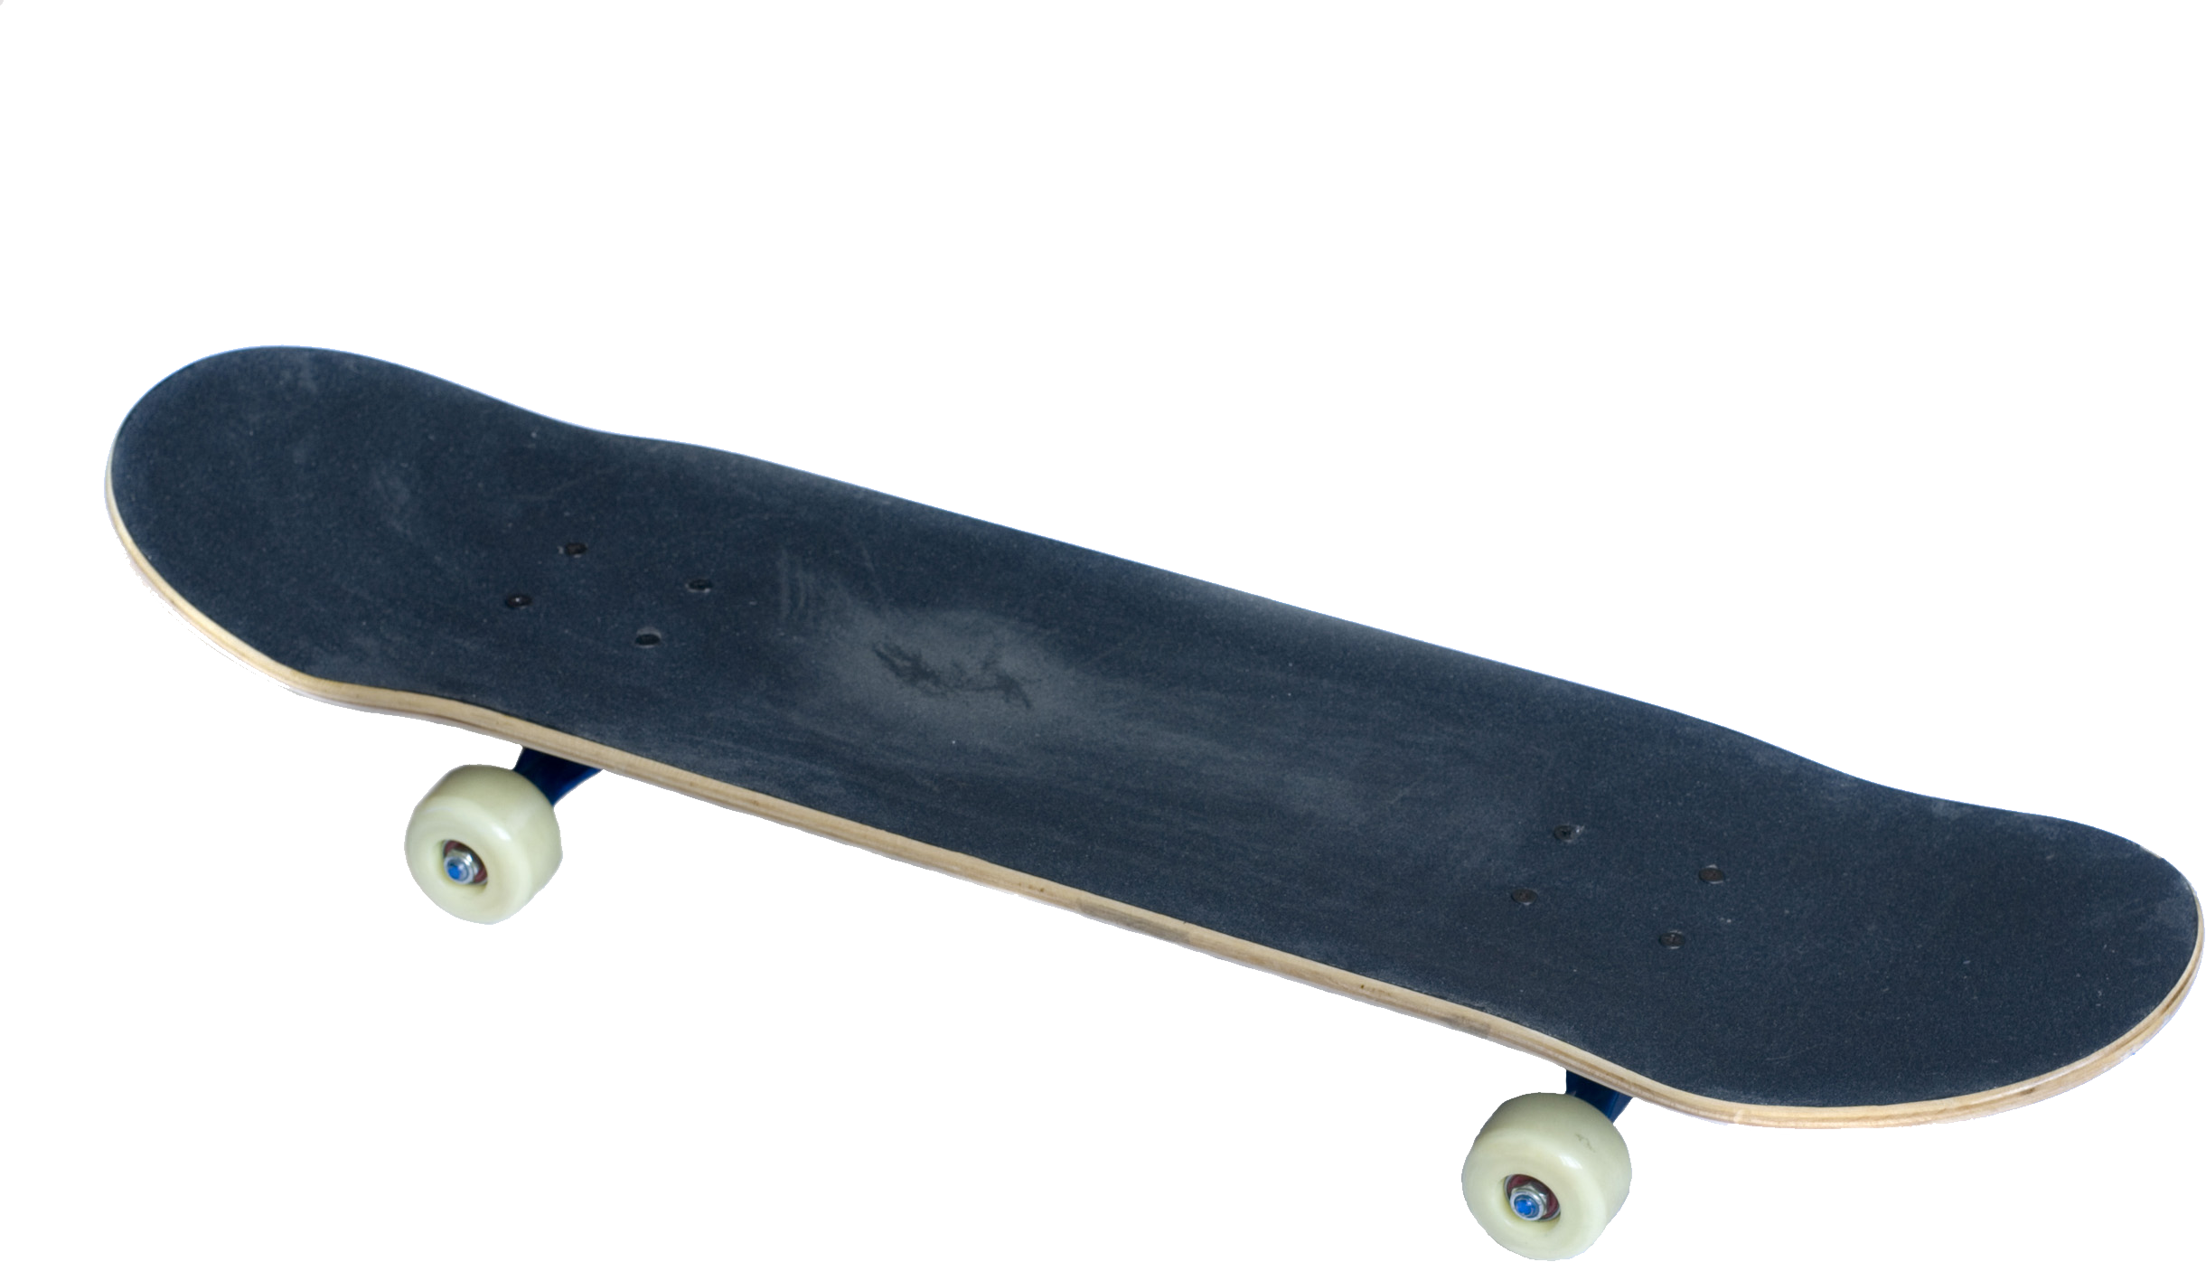
Contact & ReGISTRATION |  | Cherrie Guo – Youth Settlement Worker  cherrieg@kiwassa.ca  778-833-1485  FB: Cherrie Kiwassa | Emem-Obong Inyang – Eastside Youth Worker  ememi@kiwassa.ca  604-254-5401 EXT. 223  FB: Emem-Obong Kiwassa  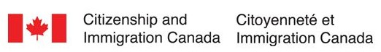 | Ryan Avola – Youth Programs Coordinator  ryana@kiwassa.ca  604-254-5401 EXT. 222  FB: Ryan Kiwassa
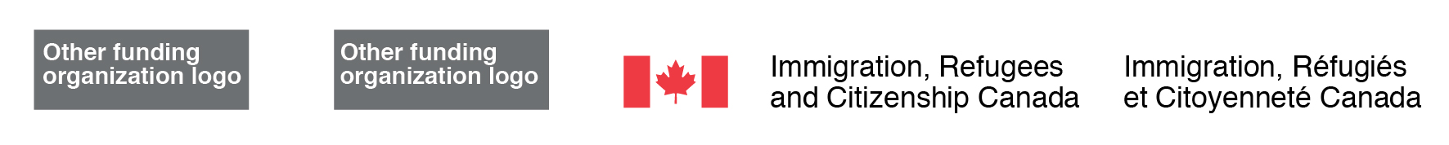
Funded By | Financé Par:
JULY /
NEWS:

Register for CHILL Skateboarding Camp! 6-week leadership and skateboard skills camp. All snacks, equipment and bus tickets provided. Ages 13 – 18 (age is flexible).

Youth Voices is a workshop for young people experiencing parental separation or divorce. Contact to sign-up.

